Geometry Name: _______________________________________________

Unit 6 Trig Study Guide Date: ____________ Period: ________ Score: __________/100

**Answer each question carefully. Place your selection choice in the box to the right.**

________ 1. What would you plug into the calculator to solve for the missing angle below?

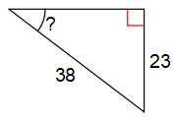A.  B. 

C.  D. 

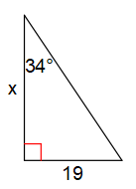

________ 2. What would you plug into the calculator to find the length of x?

A.  B. 

C.  D. 

**Extended Response. Show all of your work to receive full credit.**

Use the trig functions and their inverses to find the missing sides or angles.

Round the lengths of sides to the nearest **hundredth** and round angles to the nearest **degree**.



3. _______________ 11. 12.

4. _______________



5. _______________ 13. 14.

6. _______________

**Application problems: Draw a picture and show all work.** Round the lengths of sides to the nearest **hundredth** and round angles to the nearest **degree**.

7. The angle of depression from the top of a building to the foot of a tree on the ground is 35°. If the building is 18 meters high, how far from the base of the tree is the building?

Picture:

Answer: ____________________

8. A 5 foot tall student is standing 20 feet from their school and is looking at the top of the school with an angle of elevation of 70°. How tall is the school?

Picture:

Answer: ____________________

9. You lean a ladder against the side of a house so you can clean out the gutters. If the ladder is 12 feet tall, and it makes an angle of 68 degrees with the ground, how far up the house is the ladder?

Picture:

Answer: ____________________

10. A 12 foot tall flagpole casts a 16 foot long shadow on the ground. What is the angle of elevation from the end of the shadow to the top of the flagpole?

Picture:

Answer: ____________________