Geometry Test Review Name: ______________________________
Radicals, Pythagorean Theorem, & Special Right Triangles Date: _____________ Period: __________

Simplify the following radicals. Leave your answer in radical form – NO DECIMALS, but you may have fractions. There MUST be work shown…
1. $8\sqrt{2}∙6\sqrt{30}$ 1. _______________

2. $\sqrt{96}$ 2. _______________

3. $\sqrt{24x^{6}}$ 3. _______________

4. $\frac{\sqrt{15}}{3\sqrt{6}}$ 4. _______________

Using the ratio for a 45-45-90 triangle, fill in each box. NO DECIMALS.
5.
45 | 45 | 90
 |  | 8$\sqrt{2}$
45 | 45 | 90
7
6.

7.
45 | 45 | 90
$$5\sqrt{3}$$

Using the ratio for a 30-60-90 triangle, fill in each row. NO DECIMALS.
8. 9.  30 60 90  $$4$$ | 30 60 90  14 | 10.  30 60 90  $$4\sqrt{3}$$

Solve for each using ONLY the 30-60-90 or 45-45-90 ratio method. Do not use the Pythagorean Theorem. NO DECIMALS.
11. 60°

11. a=_____________ b=_________________

12.

c=________________ d=____________________

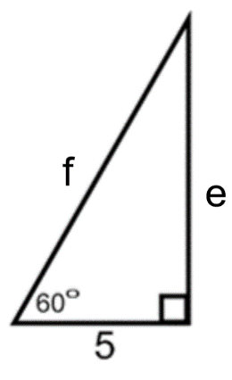
13. e=_____________

f=______________

For the application problems, use the best method. YOU MUST draw a diagram. NO DECIMALS. NO WORK – NO CREDIT.
18. What is the length of the altitude of an equilateral triangle with side lengths of 38 inches?
Picture:

Altitude = ________________
19. The bottom of a ladder must be placed 10 feet from a wall. The ladder makes a 45⁰ angle with the ground. How long is the ladder?
Picture:

Ladder = ________________

