13. The volume of a ball is 972π cm³. What is the radius of this ball to the nearest tenth?
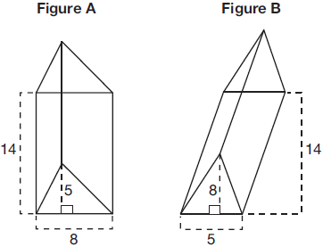
14. The circumference of the Earth is estimated to be about 7920π miles. What is the estimated volume of the Earth?
15. The diagram below shows two figures. Figure A is a right
triangular prism and figure B is an oblique triangular prism. The
base of figure A has a height of 5 and a length of 8 and the
height of prism A is 14. The base of figure B has a height of 8
and a length of 5 and the height of prism B is 14.
Use Cavalieri's Principle to explain why the volumes of these
two triangular prisms are equal.
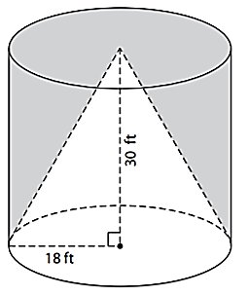
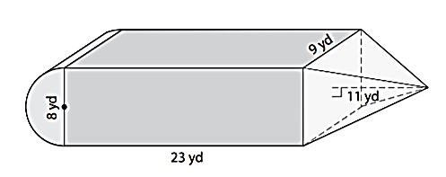
Find the volume of the composite figures below.
16. 17. (the cone has been cut
OUT of the cylinder)

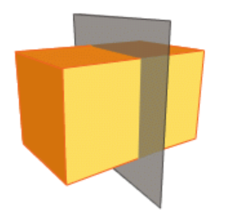
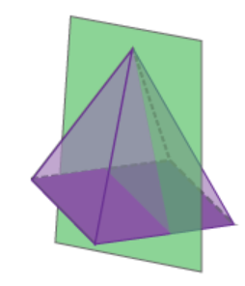
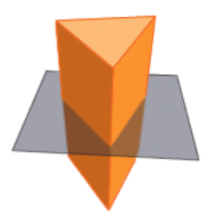
Identify the cross section.
18. 19. 20.

Population Density.
21. China has 1,386,135,802 people and an area of 3,705,219 square miles. What is China’s population density to the nearest person?

22. If a small town has a population density of 28 people per square mile, with a population of 8,326 people. What is the area of this town? Round to the nearest square mile if necessary.

23. For a certain species of animal to survive, the population density must be less than 20 per square mile. In a rectangular wildlife preserve measuring 32 miles by 10 miles, scientists counted 5,830 of the animals. Is there enough area for all the animals to survive? Explain.

