Unit 4 Quiz 2 Review
Squares
Use square ABCD below for #1-3
If $\overline{AD}=55 and \overline{BC}=x-3;solve for x$

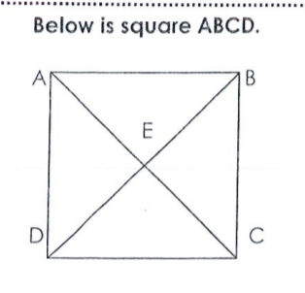

If $m<DED=4x-16;solve for x$
If $m<EDC=3x;solve for x$
Rhombi
Use rhombus ABCD below to answer questions 4-6.
If $\overline{AB}=3x-2and BC=2x-3;solve for x$

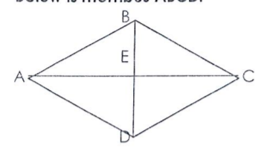

If $m<BCE=3x-1 and m<ECD=5x-5;what is m<ECD?$ (hint: solve for x first)

If $m<DEC=2x+20; solve for x$

Trapezoids
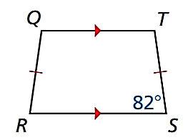

QTSR is an isosceles trapezoid. Solve for <SRQ

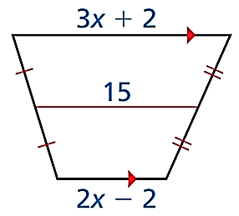
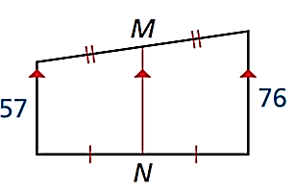

Solve for x in the isosceles trapezoid above
Trapezoid ADCB below is an isosceles trapezoid.
If AB=7x-1 and DC=8x+11; solve for x;

Can you solve for AD? Why or why not?
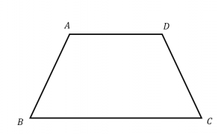

Kites
Find m<EHG
Using the fact that there are 360⁰ total in a quadrilateral, now solve for <HGF
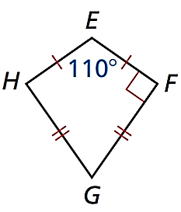

In the kite below, solve for x:

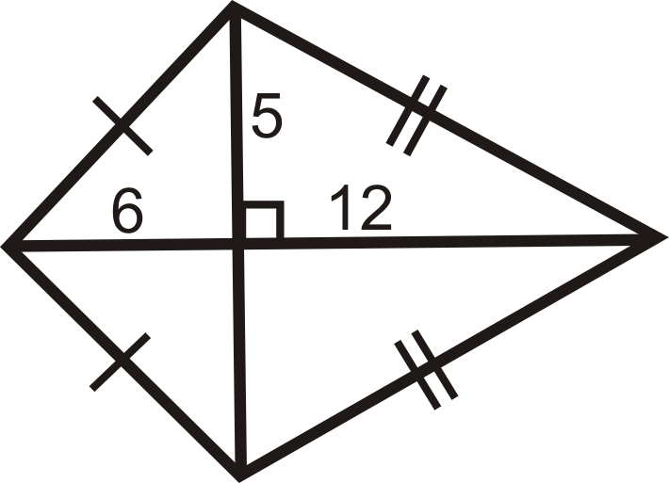
x

Solve for angle x:

