**Geometry Name: _______________________________**

**Test Review – Quadrilaterals Date: _______________________**

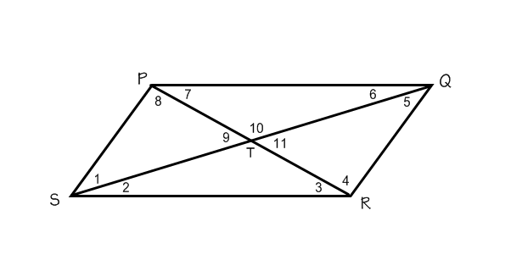

**Use parallelogram PQRS to solve the following problems:**

1. If m<PQR = 65o then m<QRS=______

2. If PQ = 25, QR = 17, and SR = 2x-5, then x=_______

3. If PT = 18, PR = _______

**4. Use the rectangle below to answer the following questions:**

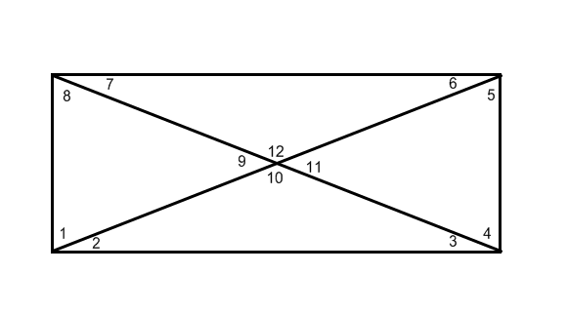

If m<1 is 70o, find all the other angles.

a. m<1 = e. m<5 = i. m<9 =

b. m<2 = f. m<6= j. m<10 =

c. m<3 = g. m<7 = k. m<11 =

d. m<4 = h. m<8 = l. m<12 =

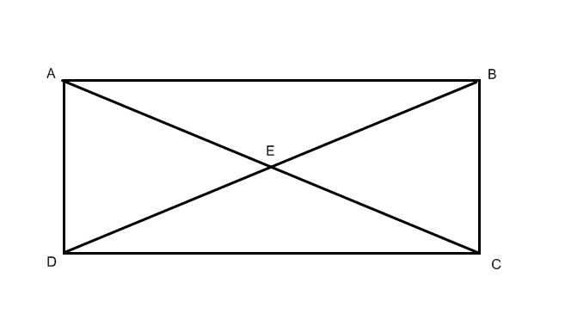**Polygon ABCD is a rectangle.**

5. If CE = 12, then BD=_______

6. If AC = 5x-4 and BD = 6x-10, find the length of .

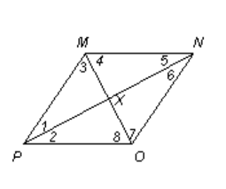**Polygon PONM is a rhombus.**

7. If MP = 2x + 5 and PO = 3x – 7, then MN = __________.

8. If mPXO = (2x + 6)0, then x = ________.

9. If m<3 = 44o, then m<6 = ________.

10. If PX = 4 and XO = 3, then PO = ________.

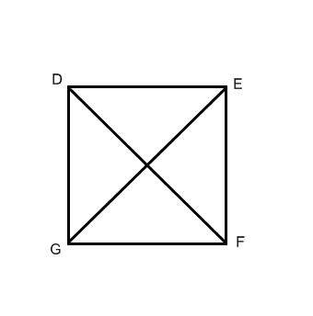**Use square DEFG to answer the following questions:**

11. Label all the angles.

12. DF = 5x - 9, GE = 3x + 19, x =________

13. If FG = 4x - 5, DG = 2x + 17, then DE=_________

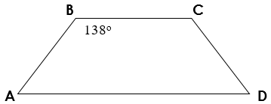**Polygon ABCD is an isosceles trapezoid.**

14. m<BAD = ________

15. m<ADC = ________

16. m<BCD = ________

17. If diagonal AC is 12x + 3 and diagonal BD is 39 – 6x,

A. find the value for x = ________

B. AC = ________ BD = ________

**Polygons LMNK are parallelograms.**



18. 19.

a. x = ________ a. x = ________

b. m<L = ________ b. LQ = ________

c. m<N = ________ c. NL = ________

d. m<MKL = ________ d. QN = ________

**Polygon WXYZ is a parallelogram. Use the following information to find the missing values.**

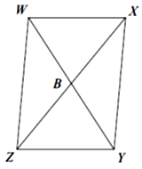XY = 3a + 10; WZ = a + 32; WX = 5b; ZY = 3b + 20; XB = 2c + 2; XZ = 6c – 2

20. a = ________ 21. XY = ________

22. b = ________ 23. ZY = ________

24. c = ________ 25. XB = ________

26. BZ = ________ 27. XZ = ________

**Use the trapezoids to find the missing values and sides.**

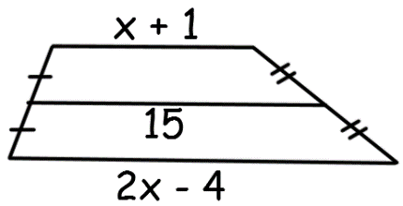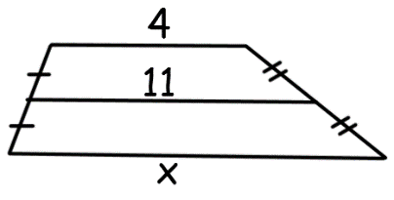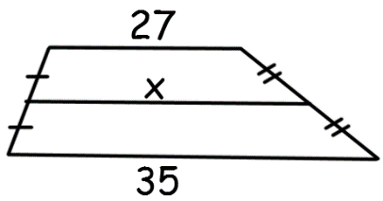

28. 29. 30.

31. **Polygon ABCD is an isosceles trapezoid.**

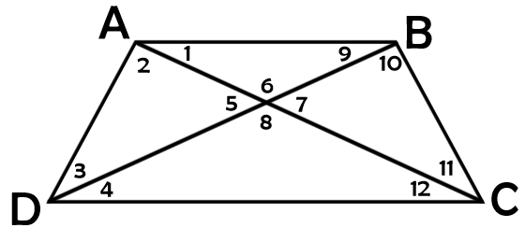**Given: m<DBC = 84**0 **and m<CAB = 29**0

a. m<1 = e. m<5 = i. m<9 =

b. m<2 = f. m<6= j. m<10 =

c. m<3 = g. m<7 = k. m<DAB =

d. m<4 = h. m<8 = l. m<ABC =

32. **Use isosceles trapezoid WXYZ to answer the following questions.**

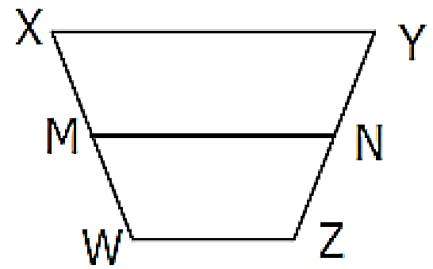a. If XW = 32, YN = _______.

b. If m<XWZ = 2x – 7 and m<XYZ = 117, then m<YZW = _______.

c. If XY = x + 2, WZ = x + 8, MN = 2x + 3, then MN = _______.

33. **Use Kite STRV to answer the following questions.**

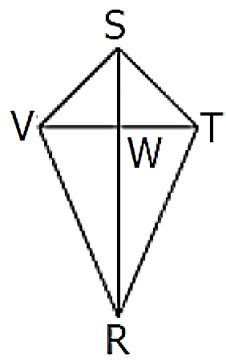

a. If SV = 18, ST = _______. b. If VW = 12, then VT = _______.

c. If m<VRS = 47 degrees, then m<TRS = _______.

d. If m<VSW = 32 degrees, then m<WVS = _______.

e. If SV = 2x + 1, ST = 4x – 7, then ST = _______.

f. If ST = 13, SW = 6, then WT = _______. (you can round to one decimal place)

g. If m<VRW = 3x + 8, m<TRW = 6x – 28, then m<VRT = _______.

h. If m<RWT = 4x – 42, then x = _______.