Geometry Date__________________________
Guided Notes – Applications of Trig (Side Lengths)

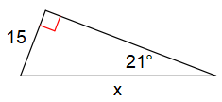
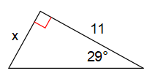
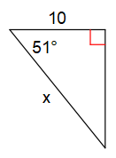
Warm-up: Find the missing side length.
1. 2. 3.

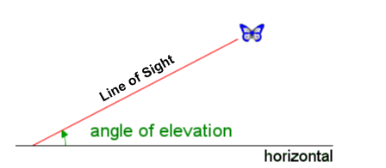
Elevation vs Depression

The ____________________________ is the angle from the
horizontal looking up to some object.

The _____________________________ is the angle from the
horizontal looking down to some object.

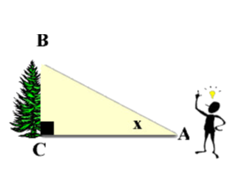

In the diagram at the left, x marks the angle of ________________
of the top of the tree as seen from a point on the ground.

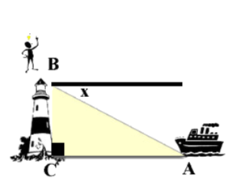
It is always ___________ the triangle.

In the diagram at the left, x marks the angle of _________________
of a boat at sea from the top of a lighthouse.

It is always ___________ the triangle.

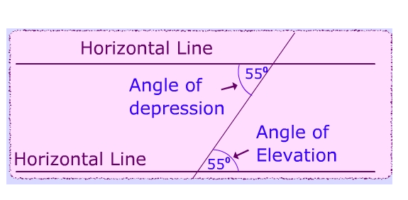
Why does it appear that an angle of elevation
and an angle of depression are the SAME?

- parallel lines cut by a ____________________

- ____________ _____________ ___________ are congruent

Steps to Solving Trig Word Problems

1. _______________________________________________________________

2. _______________________________________________________________

3. _______________________________________________________________

Examples.

1. A tree casts a shadow 21 m long. The angle of elevation of the sun is 51º. What is the height of the tree?

2. A ladder 5 m long leans against a vertical wall and makes a 65º angle with the ground. How far is the foot of the ladder from the wall?

3. A small airplane climbs at an angle of 18º with the ground. Find the horizontal distance it has flown when it has reached an altitude of 800 m.

4. You are looking at a painting on the wall at the High Museum in Atlanta. You are standing 10 feet from the wall. Your angle of elevation to view the painting is 20º. (Your eyes are about 5 feet above the floor). Find how high the top of the painting is from the floor.

5. A little boy is flying a kite. The string of the kite makes an angle of 30º with the ground. If the kite is 9 meters in the air, find the length (in meters) of the string the boy used.

6. An operator at the top of a lighthouse sights a sailboat. The point from which the sighting is made is 24 m above sea level. The angle of depression of the sighting is 10º. How far is the boat from the base of the lighthouse?

