Word Problem | Picture | Method:  - 30-60-90  - 45-45-90  - Pythagorean | Solution
Find the length of the side of a square with diagonal 10 ft.

One side of an equilateral triangle is 6 ft. Solve for the altitude (height)

Joe Geometry needs to climb up a 60 foot building to find his geometry homework. He stands 45 feet away from the building and leans a ladder against the building. How long does the ladder need to be?

A farmer has a square field with dimensions 300 ft x 300 ft. He wants to make a fence that lies along the diagonal to split the field in two equal pieces. How long will the fence need to be?

A yield sign in traffic is an equilateral triangle. If it’s standard height is $18\sqrt{3}$inches, how long is each side? | 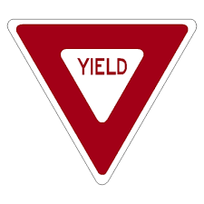
Mrs. Hamill decides to take a long vacation from school and go on a sailing trip.
Her boat starts at the dock and travels 100 meters north, then takes a 90 degree clockwise turn towards an island. The boat travels some distance to the island, then after a day of relaxation she heads back for the dock. She travels in a straight line between the island and the dock and the return distance is 125 meters. What was the distance from the first turn to the island?
If the sail of her sailboat is an equilateral triangle, how tall is the sail if the sides are 35 feet long.

You are outside flying your favorite quadrilateral, a kite, and it sadly gets stuck in a tree. When you stand 12 feet away, the angle of elevation to the spot in the tree where your kite is located is 30 degrees. If you use your American Ninja skills and climb the tree to get your kite, how high would you have to climb?

Create your own question:

