**Geometry Name: _______________________**

**Quiz Review: Circle Vocab and Central/Inscribed Angles** **Date: __________________**

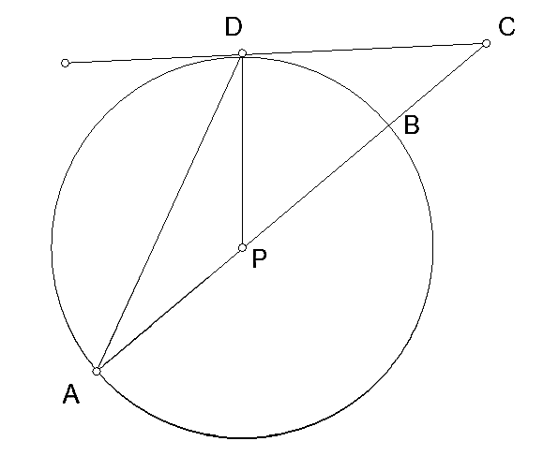**Refer to the figure at the right for questions 1-8.**

1. Name three radii of the circle.

2. Name a diameter.

3. Name two chords.

4. Name a segment tangent to .

5. Name a segment that is a secant of and   
contains a diameter.

6. Name a point in the interior of the circle.

7. Name three points that lie on the circle.

8. If AP = 4 in., find AB.

**For #9-18, write the measures in the blanks provided.**

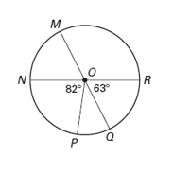

____________ 9.  ____________ 10. 

____________ 11.  ____________ 12. 

____________ 13.  ____________ 14. 

____________ 15.  ____________ 16. 

____________ 17.  ____________ 18. 

**Find the value of the variables.**



19. 20. 21.

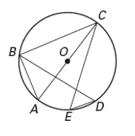**Find the measure of the arc or angle in , given .**

____________ 22.  ____________ 23. 

____________ 24.  ____________ 25. 

____________ 26.  ____________ 27. 

____________ 28.  ____________ 29. 

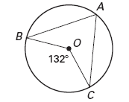

____________ 30. Find 

**Find the value of x.**

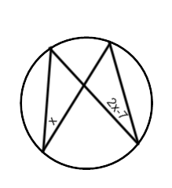

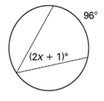_________ 31. _________ 32. _________ 33. is a diameter.

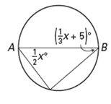

**In is a diameter.**

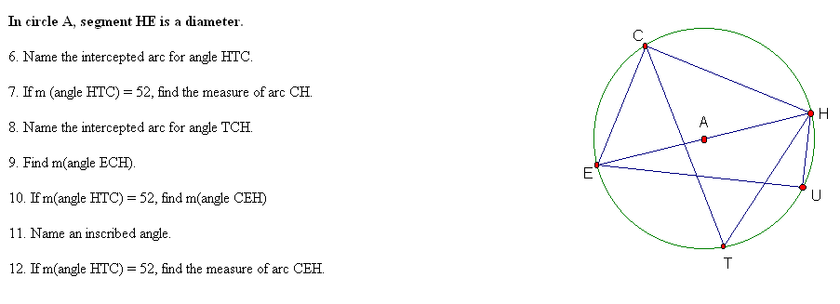____________ 34. Name the intercepted arc for.

____________ 35. If , find.

____________ 36. Name the intercepted arc for.

____________ 37. Find .

____________ 38. If, find .

____________ 39. Name an inscribed angle.

____________ 40. If , find.