Geometry Name: _______________________________
Population Density Date: ___________________
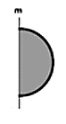
WARM-UP: Describe a solid that is formed by rotating each of these figures about line m.
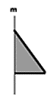
1. 2. 3. 4.

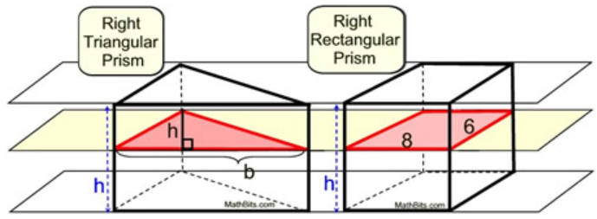
5. By Cavalieri's Principle, this right triangular prism and right rectangular prism have the same volume. If the center plane intersects the solids parallel to their bases, which of the following choices could be the base and height of the triangular cross section?
A. h = 4; b = 12
B. h = 4; b = 8
C. h = 8; b = 12
D. h = 8; b = 14

POPULATION DENSITY
The _________________________________ ______________________ of a city, county, or stat is a measure of how many people live within a given area. Population density is usually given in terms of square miles, but can be expressed using other units such as city blocks, square kilometers, etc.
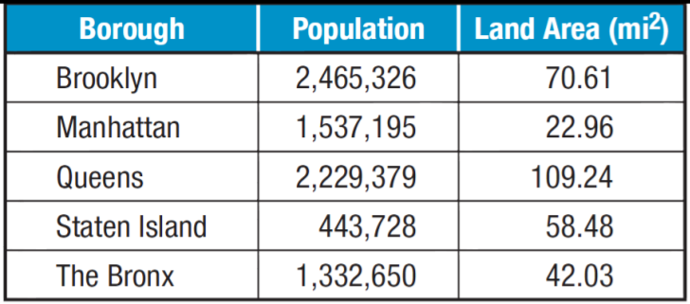
Population density =
EX: Use the table to the right to find the
population density for each borough.
Round to the nearest person.
1. BROOKLYN:

2. MANHATTAN:

3. QUEENS: 6. Which of the boroughs have the highest pop. density?

4. STATEN ISLAND: 7. Which of the boroughs have the lowest pop. density?

5. THE BRONX:

TRY THESE!!
1. A town has an area of 10.4 square miles. The town’s population is 3619. What is the population density of the town? Round your answer to the nearest whole number.

2. In 2000, Texas had about 2.74 persons per household, 7,393,354 households, and a land of area of about 261,797 square miles.
A. What was the population density of Texas is 2000?

B. If the population in 2009 was about 24,782,302, how did the density in 2009 compare to the density in 2000?

3. For a certain species of animal to survive, the population density must be less than 15 per square mile. In a rectangular wildlife preserve measuring 20 miles by 15 miles, scientists counted 3,740 of the animals. Is there enough area for all the animals to survive? Explain.

4. A county has a population density of 257 people per square mile. The county population is 4288. What is the area of this county? Round to the nearest square mile if necessary.

