Multiplying Polynomial Applications
Solve for the perimeter and area of each shape below
Rectangles:
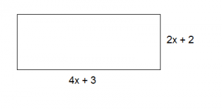
Perimeter: Add up all sides Area: multiply length x width

Perimeter | Area

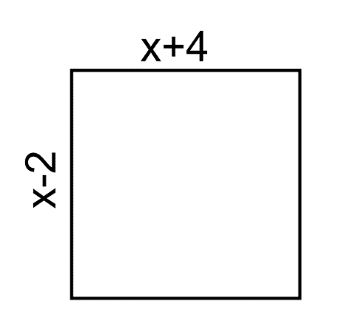

Perimeter | Area

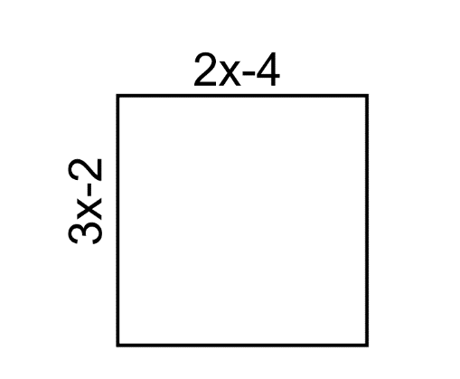

Perimeter | Area

- Squares:
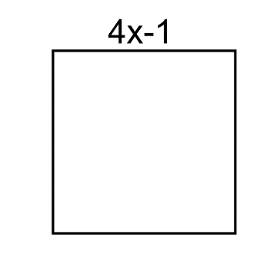
Perimeter: Add up all sides Area: multiply side x side, or side²

Perimeter | Area

- Triangles:
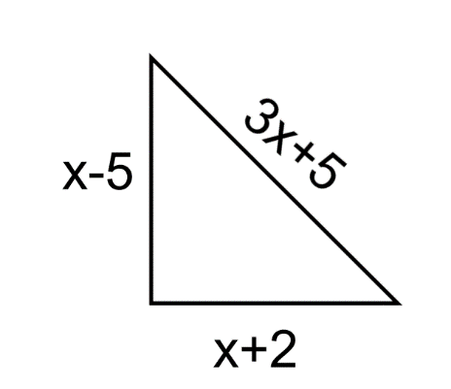
Perimeter: Add up all sides Area: ½(base)(height)

Perimeter | Area

- Challenge:
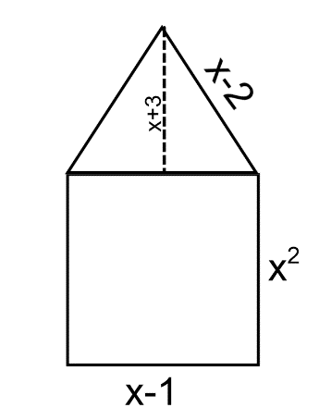
Hint: Break up into rectangle and two triangles, solve each, then add together at end

Perimeter | Area

