Perpendicular Lines  2 lines that intersect to make a right angle. | 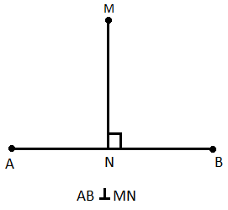
Parallel Lines  2 lines that never intersect | 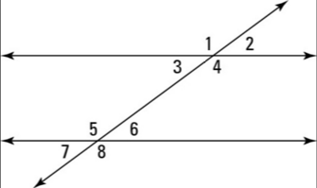
Transversal
A line that cuts a set of parallel lines
Supplementary Angles
2 angles that add up to 180 degrees

Corresponding Angles
2 angles that lie in the same position on each parallel line while touching the transversal
They are congruent angles
Ex.) 1/5, 2/6, 4/8, 3/7
Same Side Interior Angles
Angles that lie on the inside of parallel lines on the same side of the transversal. They have a supplementary relationship.
Ex.) 4/6, 3/5
Same Side Exterior Angles
Angles that lie on the outside of the parallel lines on the same side of the transversal. They have a supplementary relationship.

EX.) 1/7 or 2/8
Alternate Interior Angles
Angles that line inside the parallel lines on opposite sides of the transversal
They are congruent angles.
Ex.) 4/5, 3/6
Alternate Exterior Angles
Angles that line outside the parallel lines on opposite sides of the transversal
They are congruent angles.
Ex.)2/7, 1/8
Vertical Angles
A pair of opposite angles made by two intersecting lines
They are congruent angles.
Ex.) 1/4, 5/8

