**Geometry Name: ___________________________**

**Guided Notes – Trigonometric Ratios Date: _______________________**

**Triangle Sides (based on θ)**

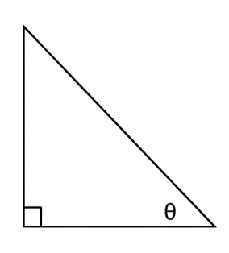

**Opposite leg**

**_____________ ____hypotenuse_**

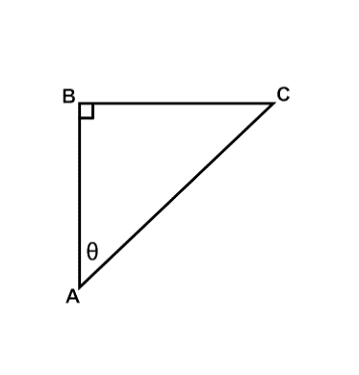

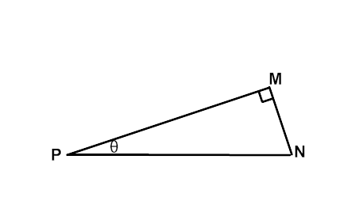

**__adjacent leg_**

Which side is the hypotenuse? _________ Which side is the hypotenuse? _________

Which leg is opposite θ? ____________ Which leg is opposite θ? ____________

Which leg is adjacent to θ?__________ Which leg is adjacent to θ?__________

**What are the Trigonometric Ratios?**

|  |  |
| --- | --- |
| **Sine** |  |
| **Cosine** |  |
| **Tangent** |  |
|  |

**SohCahToa**

SOH **Sine** equals _________________ over _________________

CAH **Cosine**  equals _________________ over _________________

TOA **Tangent**_ equals _________________ over _________________

**How do we use these ratios?**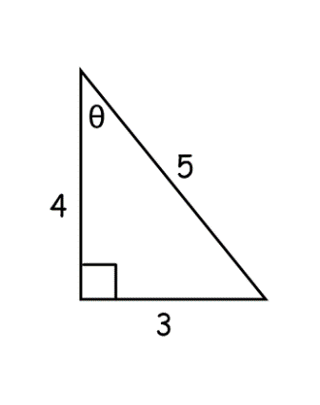

sin θ = ______ = ______

cos θ = ______ = ______

tan θ = ______ = ______

**Find the missing side and evaluate each for sin θ, cos θ, and tan θ.**

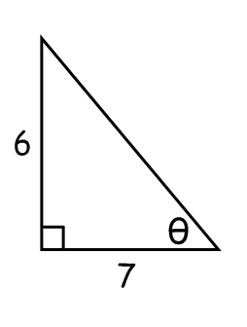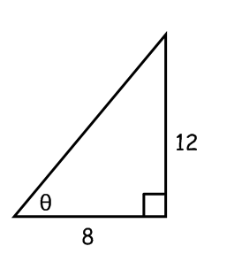

** **

**How would you solve the following problem?**

Suppose J and K are complementary angles in a right triangle. The value of tan J = .

What is the value of sin J?

1. Draw and label a triangle for the problem.

2. Use the given trig ratio to label the lengths of two sides. Then use the Pythagorean Theorem to find the third side.

3. Using the measures of the sides of the triangle, find sin J.