Geometry Name: _________________________
Cross Sections & Cavalieri’s Principle Date: _____________
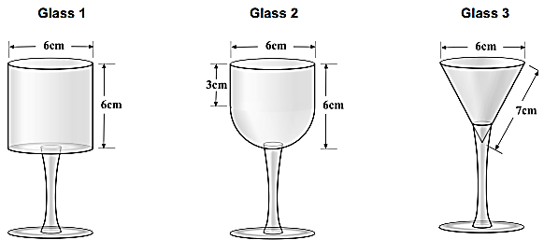
WARM-UP: Find the volume of each glass. Which of the following holds the most liquid?

CROSS SECTIONS – The shape you get when cutting straight through a 3-dimensional shape.
 | NAME | SHAPE OF BASE | Which figure results when you slice it PARALLEL to the base? | Which figure results with you slice it PERPENDICULAR to the base? | Which figure results when you slice it DIAGONAL to the base?
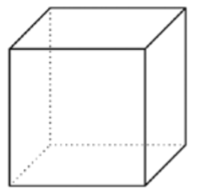
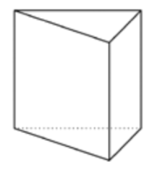
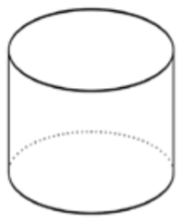
 | NAME | SHAPE OF BASE | Which figure results when you slice it PARALLEL to the base? | Which figure results with you slice it PERPENDICULAR to the base? | Which figure results when you slice it DIAGONAL to the base?
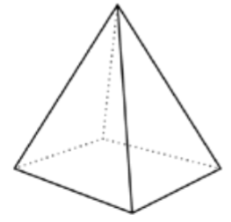
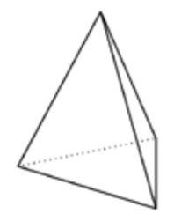
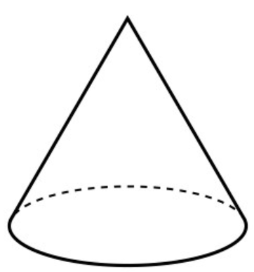
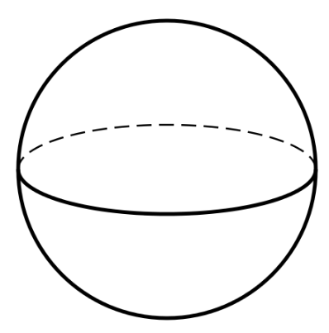

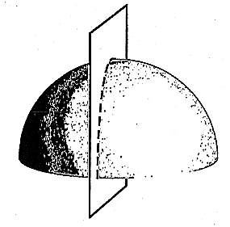
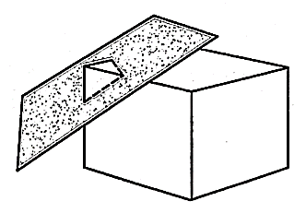
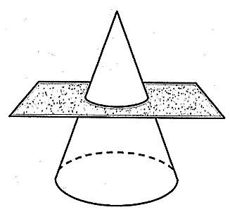
PRACTICE
What are the shapes of the cross sections below?
1. 2. 3.

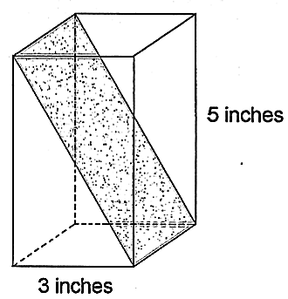
4. Andrew had a piece of foam in the shape of a
rectangular prism as shown below. The base is a square
with sides 3 inches long, and the piece is 5 inches tall.
He cut the foam along the diagonal plane shown by
the shaded area. What is the area of the shaded
diagonal plane?
Bonaventura Cavalieri – He was an Italian mathematician born
in 1598 – 1657. He is known for his work in optics, motion, calculus,
and introduction of logarithms.
CAVALIERI’S PRINCIPLE
- The volumes of two objects of the same height are equal if the areas of their corresponding cross sections are equal.

These pieces maintain the SAME volume regardless of how they are moved!!
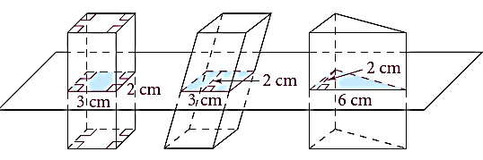
Find the area of each cross section below.

Based on what we know about the areas of the cross sections, what can we assume about the volumes (assuming all three heights are the same)?

The same volume formula applies whether it’s a right prism or an oblique prism.

PRACTICE:
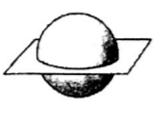
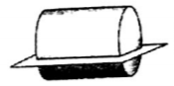
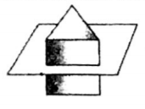
Name the cross section.
1. 2. 3.

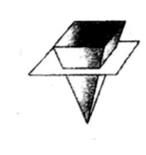
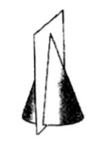
4. 5. 6.

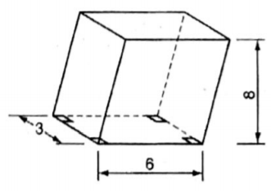
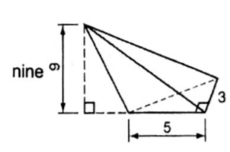
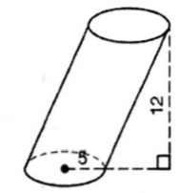
Find the volume of each oblique figure.
7. 8. 9.

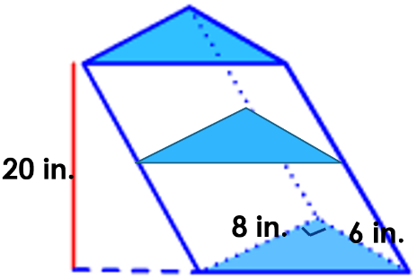
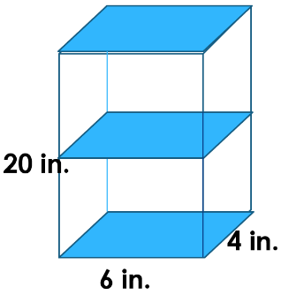
10. Which figure has more volume?

11. Collin is going to change the oil in his Jeep. He has two funnels. A has a diameter of 6 inches and is 5 inches deep. B has a diameter of 5 inches but is 7 inches deep. He wants to use the funnel with the greatest volume to minimize the chance of spilling the oil. What are the volumes of the funnels? Which one should he use A or B?

