### Name: __________________________________________ Date: _____________________________

**Circles: Arc Length & Area of a Sector**

|  |
| --- |
| **Circumference of a Circle**  or |

Find the circumference of each circle:



14.3 in.

33 meters



|  |
| --- |
| **Arc Length of a Circle** |

1. Find the arc length of :

8 in.

70°

A

B

1. Find the radius of :

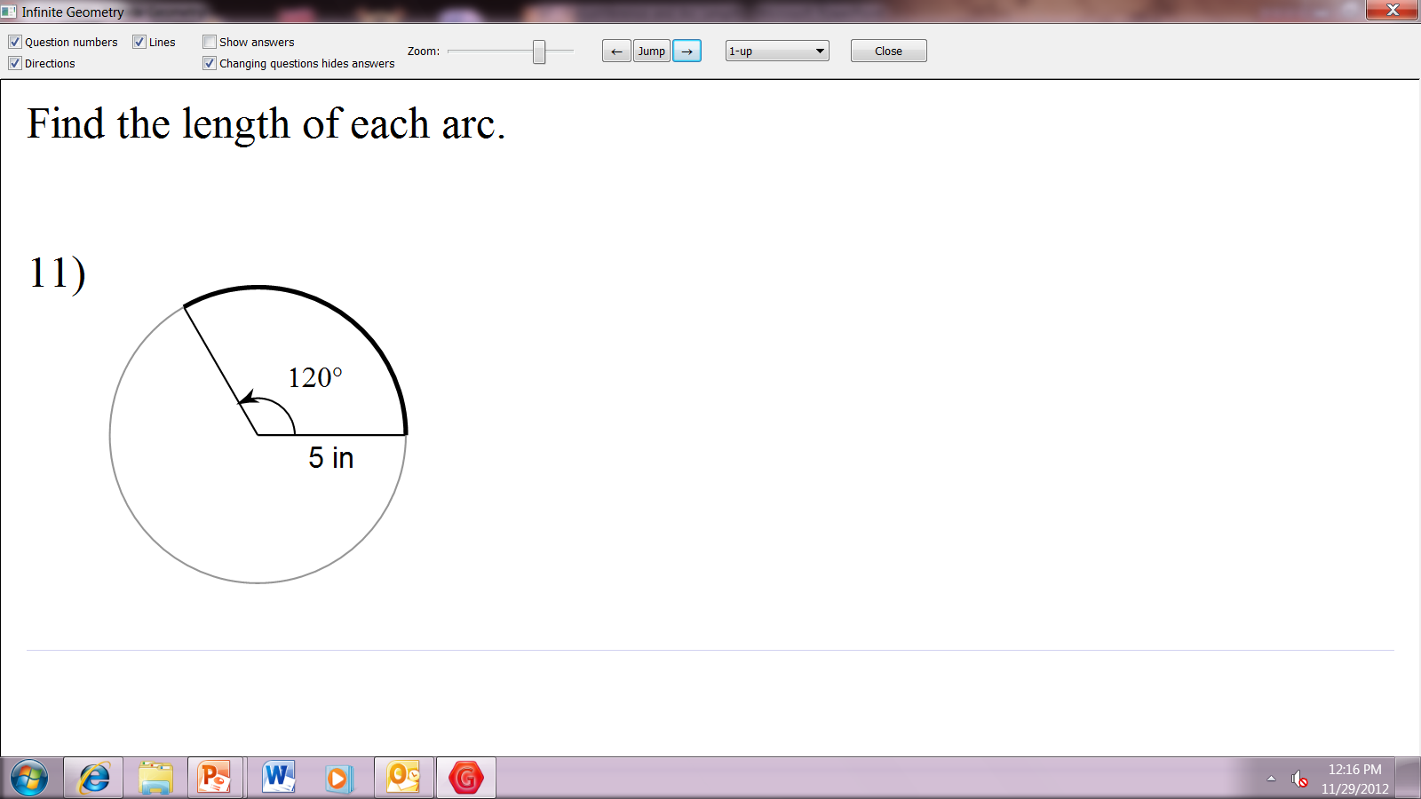

|  |
| --- |
| **Area of a Circle** |

Find the area of each circle:

53 cm.

7.6 yd.



|  |
| --- |
| **Area of a Sector of a Circle** |

1. Find the area of the sector formed by .
2. Find the area of the sector.

6 in.

60°

A

B

C

